**How to use bulk API template**

**Step1**:- First user need to create two csv files named POST-Endpoints and GET-Endpoints in jmeter bin folder as below or we can provide already created files in bin folder with below format

For Post requests as below

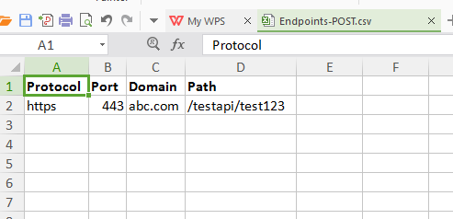

For Get requests as below

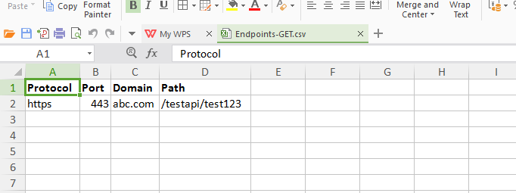

**Step-2**:-User needs to create json files for API body data and place in any location of your system. Suppose user placed in D drive under API-Test folder then user needs to provide D:\API-Test\\ in POST request body data section in below string

${__FileToString(${__eval(**D:\API-Test\\**${__threadNum}.json)},,)}

How to create json file for body data

1. Open the notepad
2. Paste your json or xml body data in it
3. Save it as File name with extension .json and **Save as type** should be as **All Files**
4. Last step if you need to test 10 json files and place 10 json files you need to increase the threads by 10 in POST-API it will fetch body of 10 api one by one from your saved json

OR

We can provide already created .json file template in jmeter bin under specific folder like API-Body, user can create more files by referencing template files and in this case user needs to define the same location where he saves all json files in body data in below string

${__FileToString(${__eval(**C:\Users\apache-jmeter-3.3\bin\API-Body\\**${__threadNum}.json)},,)}

Step 3:-If user have common headers for both type of requests then he can put the headers in **For-Common-Headers** config element given under TestPlan other wise he can define in **POST-Header Manager** and **GET-Header Manager** separately

Step:-In this template we also have common view results tree report and separate view results tree reports. With the help of common view results tree report user can see the reports for all requests and with separate view results tree reports user can view specific requests reports.